# Procedure to reset LDAP (NA) user’s password

**The main case where this procedure is needed, is when a user can’t access the NA with his Windows password, even though his NA account is properly configured.**

When the user changes his Windows password, it is synchronized with the LDAP password.

But the synchronization doesn’t work the other way around. So when there is an unsynchronization with the LDAP password (that allows access to the NA, GitHub,…) here is the procedure so that the user can reset his LDAP password to be the same than his NA password.

1. Go to the webpage: <https://ldapauth/_users/>

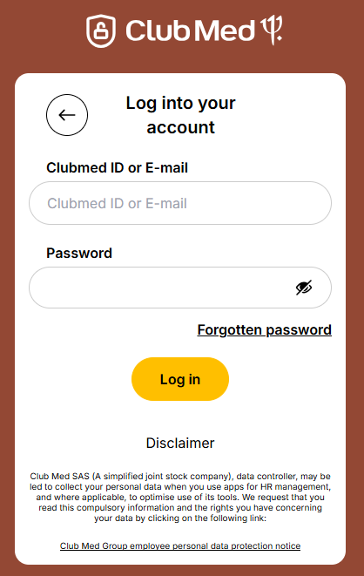

1. Before clicking on “Forgotten password” tell the user he will receive the following email to reset his LDAP (NA) password:

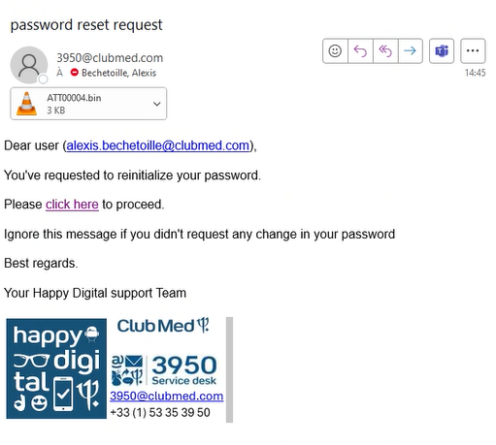

1. Now click on “Forgotten password”, put the user’s email address and click on “Submit”:

1. The user will receive the email above, by clicking on the hyperlink “click here” he will be able to reset his LDAP password so it can match his Windows password.